Español Project
“MI RUTINA DIARIA”
DUE: Friday, 10.10.16

GOALS AND OBJECTIVES

- Utilization of current unit vocabulary
- Understanding, practice, and proficiency in the meaning and usage of reflexive verbs
- Practice and improvement in written and spoken Spanish
- Incorporation of technology into second language acquisition

PROJECT DETAILS:

- Create a video depicting 10 daily routine activities, beginning with a time of awakening and ending at bedtime. The star of the video is you! You must use 8 reflexive verbs in the first person “Me despierto”, etc. discussing your daily routine, and 2 non-reflexive verbs also conjugated in the first person. In addition to the video clip, you must narrate (in your voice) the action being depicted. Be creative! You can use props as needed.

OR

- Create a 10 slide [minimum] PowerPoint© presentation that accurately depicts a minimum of 10 different events in a daily morning routine, beginning with a time of awakening and ending at bedtime. All slides must have the written conjugation for each daily routine, as well as a photo or video depicting the activity. In addition to the video clip, the student must include a narratives (in your voice) of the action being performed.

OR

- Create a Visual Presentation depicting 10 separate categories of your daily routine. You must include 8 reflexive verbs, conjugated in the first person “Me Despierto”, as well as 2 non-reflexive verbs, also conjugated in first person. Each category must have a picture either drawn by you, cut out from a newspaper or magazine, or printed that clearly depicts the activity being performed. Each picture should include a complete sentence of the activity. You will present this orally to the class. Non-negotiable.

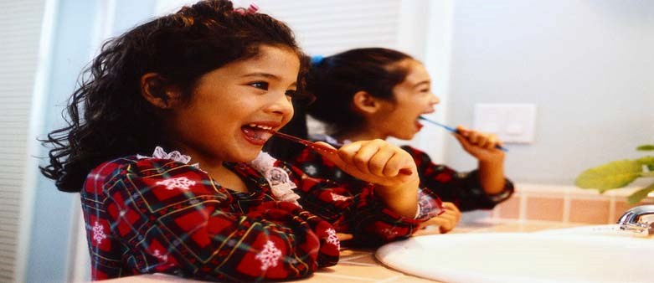
Me cepillo
los dientes diariamente.
Es bueno cepillarme
los dientes después de comer.
Me cepillo
los dientes diariamente.
Es bueno
cepillarme
los dientes después de comer.

Sample slide:

GRADING
Mi Rutina Diaria project will be assessed in the both the PROJECT and SPEAKING ASSESSMENT categories. Visual communicability and grammatical accuracy will be evaluated and assessed in the PROJECT category and verbal communicability [accuracy] and pronunciation will be evaluated and assessed in the SPEAKING ASSESSMENT category. Note: All presentations must be submitted on a portable USB flash [thumb] drive, or saved to your student account. The attached grading rubric will be used in the project’s assessment.

CONTENT AND COMMUNICABILITY  GRAMMATICAL ACCURACY
SCORE |  | CRITERIA
10 | Exceeds Standard | All content requirements are satisfied. Complete grammatical accuracy is attained. The assignment goes beyond what is expected.
8 | Meets Standard | Most content requirements are satisfied and the assignment meets set expectations. Near complete grammatical accuracy is attained.
6 | Approaches Standard | Assignment satisfies many objectives. Content and communicability is weak. Grammatical accuracy lacking.
4 | Below Standard | Assignment needs overall improvement. Few objectives satisfied. Poor attempt at meeting requirements.

 | VERBAL COMMUNICABILITY  PRONUNCIATION ACCURACY
 | SCORE | CRITERIA
10 | Exceeds Standard | Outstanding verbal communicative accuracy. Enunciation and pronunciation is impeccable. The assignment goes beyond what is expected.
8 | Meets Standard | Good verbal communicability. Enunciation and pronunciation is good. Near complete verbal communicative accuracy is attained.
6 | Approaches Standard | Assignment satisfies many objectives. Fair verbal communicability. Enunciation and pronunciation is weak. Verbal communicative accuracy is weak.
4 | Below Standard | Assignment needs overall improvement. Enunciation and pronunciation is poor. Few objectives satisfied. Poor attempt at meeting requirements.

Nombre ______________________________________________ Bloque _________

